

**An Undergraduate Internship Project on Healthcare Chatbot for Intelligent Doctor Recommendation**

Abir Ehsan Evan

Student ID: 1930670

**Summer, 2025**

Supervisor:

**Azwad Abid**

**Lecturer B**

Department of Computer Science & Engineering Independent University, Bangladesh

**September 13, 2025**

# **Submission-02**

**Department of Computer Science & Engineering**

**Independent University, Bangladesh**

**Chapter 3**

**Project Management & Financing**

* 1. **Work Breakdown Structure**

A Work Breakdown Structure (WBS) is a hierarchical decomposition of the total scope of work to be carried out by the project team. It provides an organized and detailed description of all project deliverables and activities, breaking the complex project into smaller, more manageable components. For the Healthcare Chatbot project, the WBS aims to assist in planning, organizing, and controlling the development process by clearly defining tasks, facilitating resource allocation, and enabling effective progress tracking. When integrated with project scheduling tools like Gantt charts, the WBS ensures well-defined responsibilities, promotes team collaboration, and serves as an indispensable instrument for simplifying the execution and oversight of the project from inception to deployment.

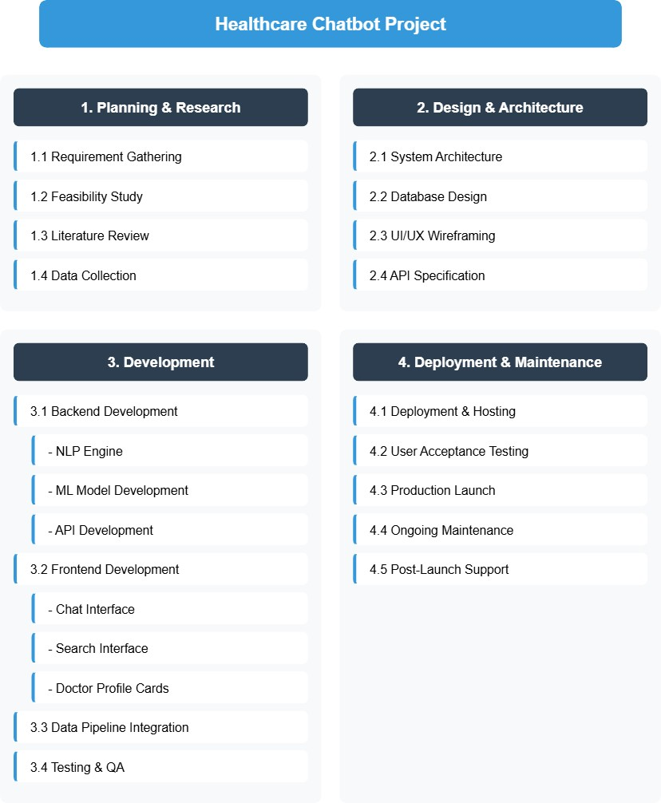

Figure 3.1: Work Breakdown structure Diagram

* 1. **Process/Activity wise Time Distribution**

The successful and timely completion of the Healthcare Chatbot project is contingent upon the effective allocation of time to each sequential task and process. Identifying the critical path the longest sequence of tasks that must be completed on time for the entire project to finish on schedule is paramount. Tasks on this path, such as the development of the core NLP engine and the machine learning model for symptom analysis, are interdependent; any delay in one directly impacts the project's final deadline. By understanding these temporal relationships and analyzing the critical path, the project manager can allocate resources efficiently, prioritize critical tasks, and ensure that key milestones are achieved within the stipulated time frame, thereby guaranteeing the project remainsontrack.

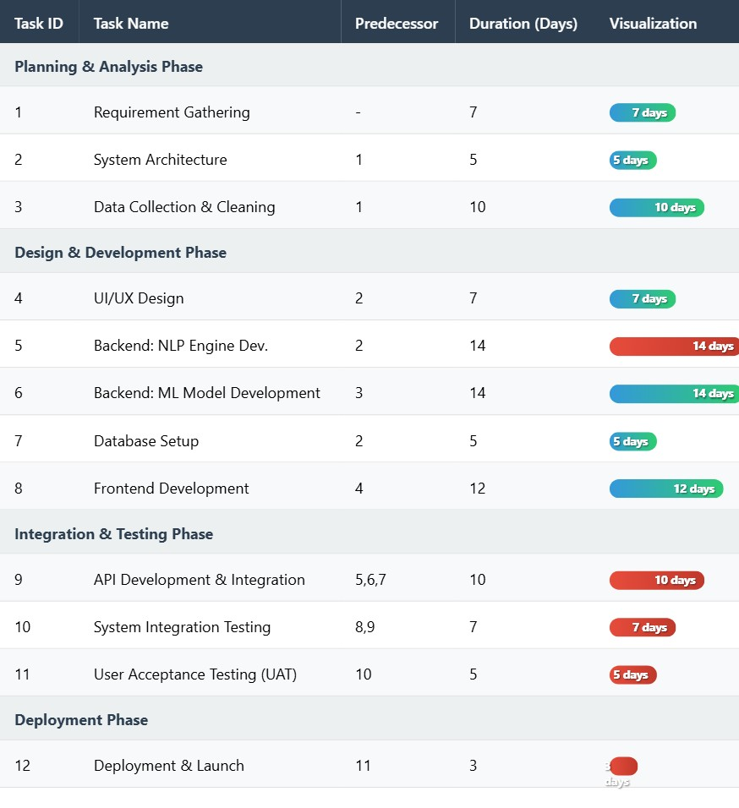

Figure 3.2: Process/Activity wise Time Distribution Diagram

* 1. **Gantt Chart**

The planning and scheduling phase for the Healthcare Chatbot project was conducted using a Gantt chart, a vital tool in modern project management for visualizing project timelines, task dependencies, and progress. The chart provided a clear overview of all activities, their start and end dates, and the team members responsible, ensuring alignment and accountability. While the developers were the most critical resource, the project also required standard office computing equipment, development software licenses, and server infrastructure for testing. Each team member was assigned distinct duties with specific deadlines, fostering a collaborative environment to complete the project successfully. The detailed Gantt chart, crucial for tracking the project's progression against planned schedules, is maintained internally using project management software.

* 1. **Process/Activity wise Resource Allocation**

The successful execution of the Healthcare Chatbot project necessitates a deliberate and strategic allocation of human, technological, and financial resources across its various phases.

* **Planning & Research Phase:** This phase requires **Data Analysts** and a **Medical Domain Expert** (or advisor) to accurately gather requirements, understand medical terminologies, and ensure the symptom-disease dataset is correctly structured. Their expertise is crucial for defining the project's medical scope accurately.
* **Design & Architecture Phase:** **UI/UX Designers** are tasked with creating an intuitive and empathetic user interface for the chat and search experiences. Simultaneously, a **Solution Architect** or **Senior Developer** designs the overall system architecture, including the tech stack and database schema.
* **Development Phase:** This is the most resource-intensive phase.
  + **Backend Development:** Requires **Python Developers** with expertise in Flask/FastAPI for building the web server and APIs. An **NLP/Machine Learning Engineer** is essential for developing the symptom analysis and classification algorithms.
  + **Frontend Development:** A **Frontend Developer** (proficient in JavaScript, React/Vue.js) builds the interactive chat interface and the doctor search/browsing pages.
  + **Data Engineering:** A **Data Engineer** or a developer handles the integration and preprocessing of the various CSV datasets to ensure they are clean, consistent, and ready for use by the backend systems.
* **Testing & QA Phase:** **Quality Assurance (QA) Engineers** are responsible for designing and executing test cases, including unit tests, integration tests, and user scenario tests to ensure the chatbot is accurate, reliable, and bug-free.
* **Deployment & Maintenance Phase:** A **DevOps Engineer** or system administrator handles the deployment of the application to a production server (e.g., cloud hosting like AWS, Heroku, or a private server). Post-launch, a dedicated **Support & Maintenance** team (which can include developers from the team on a rotational basis) is needed for ongoing monitoring, updates, and user support.

This optimized allocation of human resources ensures that the right expertise is applied at the right time, guaranteeing both the quality of the product and the efficient use of the project budget.

* 1. **Estimated Costing**

1. The total cost of the Healthcare Chatbot project can be broken down into a few key categories. The most significant expense by far will be the cost of the team. This includes the salaries and benefits for all the developers, designers, testers, and a medical domain expert needed to build the application over the estimated three to four-month development period. Since this is a technical project, skilled personnel represent the largest investment.
2. Beyond team costs, there are expenses for software and tools. While we plan to use many free and open-source resources, there may be some costs for professional design software, project management tools, or premium application programming interfaces (APIs) if advanced features are needed.
3. To make the chatbot accessible to users, it must be hosted on the internet. This involves recurring server hosting fees from a cloud provider, which will vary depending on the amount of traffic and data the application handles. Finally, there are ongoing operational costs to consider after the launch. This includes renewing the website domain name, maintaining the server, and allocating a budget for occasional support and updates, such as adding new doctors to the system or fixing any minor issues.
4. A crucial part of financial planning is setting aside a contingency fund, typically 10-15% of the total budget. This fund acts as a safety net for unforeseen challenges or additional feature requests that arise during development. Sound financial oversight is essential to ensure the project is completed within its allocated budget.